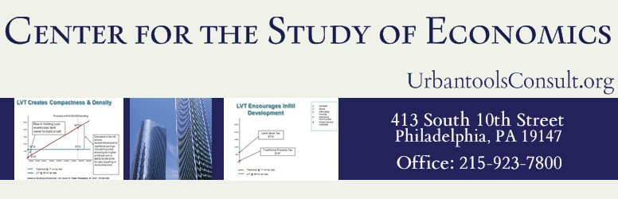

**The Left Forum June 8, 2013 Pace University**

**Occupy the Commons: A Proposal for Regional Action**

**A Blueprint for Larger Action**

Joshua Vincent, Director Center for the Study of Economics

Much of the discussion this weekend and in this panel will concentrate on analysis of tremendous forces that play out internationally in seemingly beyond the control of marginalized people and groups. National borders are of little comfort as poverty and hopelessness exist within a few minutes travel from the shining columns of condominiums in Manhattan or San Francisco and gated communities in exclusive suburbs that have effectively shut out the full spectrum of human existence and economics.

The role that CSE plays is similar to dozens of grassroots foundations and NGOs who attempt to gauge and test the disconnect between people and communities and tried to implement solutions at a local or regional level and thereby convince or compel at ever higher levels of government and economies.

We declare that radical and permanent change for a better world starts simultaneously at the **international** level and the **neighborhood** level. We concentrate here on the micro level; in concert with the idea that organization for a better life needs local input and control of that essential ingredient to more prosperity for all: the land. We finish with a doable **regional** proposal.

**Land Value Taxation**

The Center comes to this forum today as an organization that works with postindustrial, poor or declining urban areas. These communities exist adjacent or intermeshed with quite prosperous and wealthy communities. We have worked actively to leverage the “idea of Commonwealth” into practical public and policy debate.

We transform tax structures that implausibly take from wages, small businesses and large, and stakeholders in the economy to comfort those that have been able to grab and hold publicly created wealth in its various forms, either from monopoly privilege or the earth that we all need to exist.

The Center has been able to work with communities to transform their tax system into one that does not depend upon those with little, either is wealth, political, and economic power. Our vision relies on calling those holders of misappropriated community created value and *reclaiming that value to the people*. What are some examples? What does this mean?

The city of Pittsburgh Pennsylvania used land value taxation from 1910 to 2001. In that time which saw the collapse the steel industry, white flight and sprawl to the suburbs, Pittsburgh nearly alone among Rust Belt cities managed to hold its own, survive and now it thrives.

Nearly all city leaders and most economists that if studied the city credit the land value tax with being the one tool that helps protect all neighborhoods and all income levels from the wounds of policy and economic mistakes of the past.

The classic but contemporary study of land value tax performed by University of Maryland professors Oates and Schwab using building permit data and statistical regression analysis to determine that Pittsburgh, alone of Rust Belt cities from the mid-1970s to the late 1980s. Pittsburgh saw an increase in taxable building permits, at a time of national recession and regional collapse.



*Land Value Tax Outcomes Study Pittsburgh Pennsylvania*

**The Philadelphia Experiment**

LVT has also been the subject of hot debate in the city of Philadelphia. Currently, a non-utilization tax on vacant land and certified blighted buildings is the only legislation on the landscape. However, again, the stark transfer property tax burden from poor and working-class neighborhoods to wealthy areas and underutilized valuable land is clear:

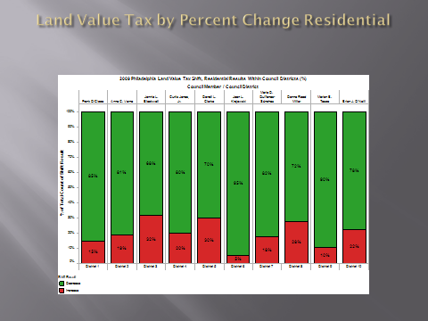

*Land Value Tax Outcome for Philadelphia Council Districts Residential Properties 2016*

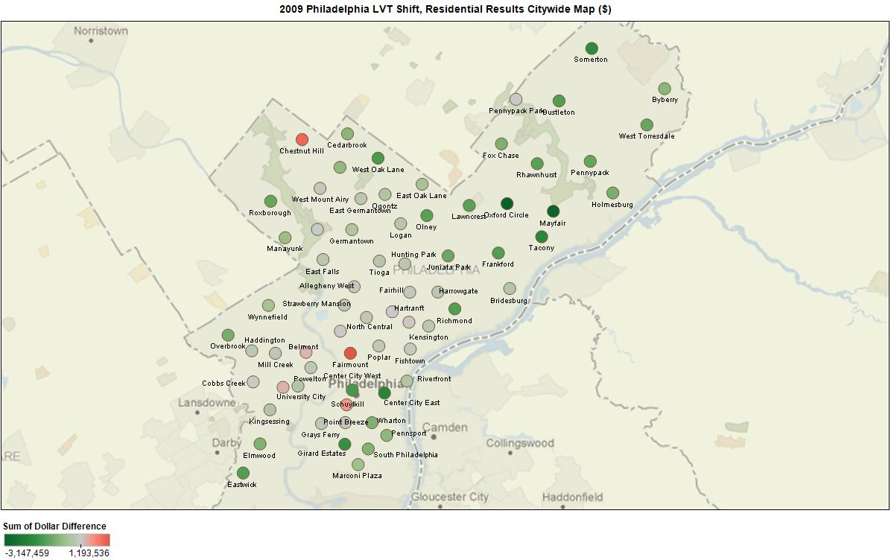

**What is an example of taxation of labor and capital hurting the chances for a city’s recovery?**

An example, the tax levy chasm between aging cities and sprawling – but “hot” – suburban counties, dooms the poorest of places – Baltimore City– to the role of non-competitive supplicant. The Baltimore Metro region is instructive as an example because the major governmental “engines” are the counties.

When Baltimore City’s tax rates compare to surrounding jurisdictions, the competition quandary is apparent.

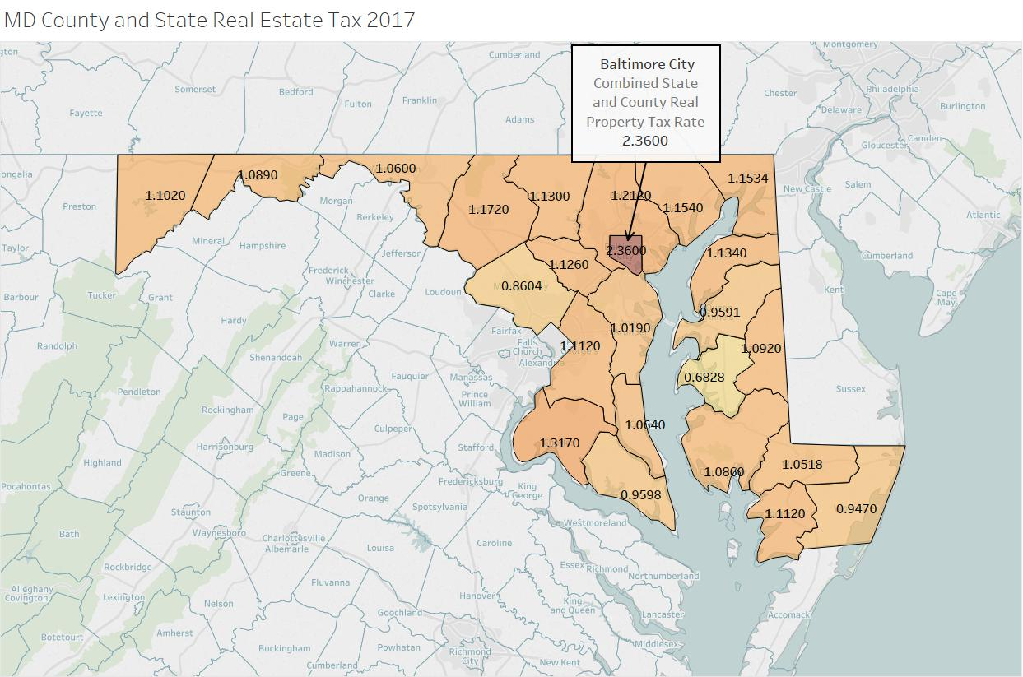

Figure 1

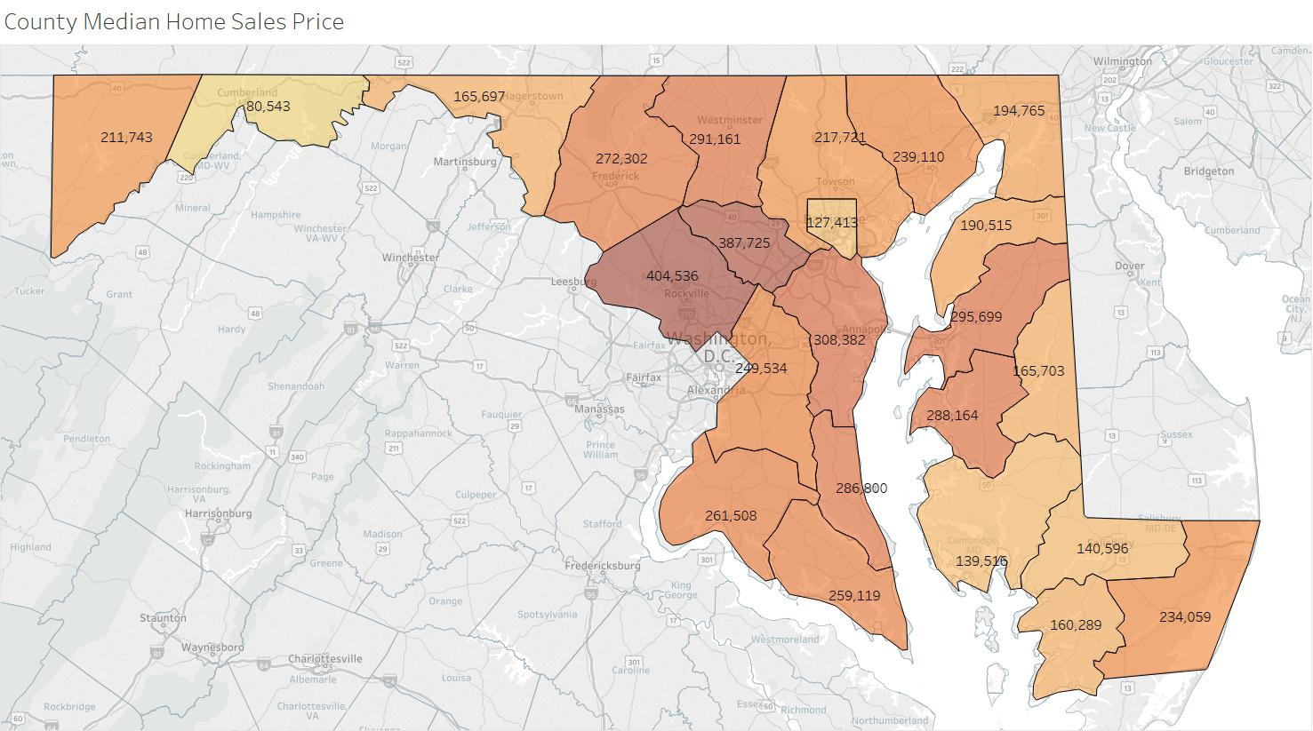

Figure 2

With insignificant residential value, how can Baltimore pay for needed resources to begin to ameliorate its problems, which are legend?

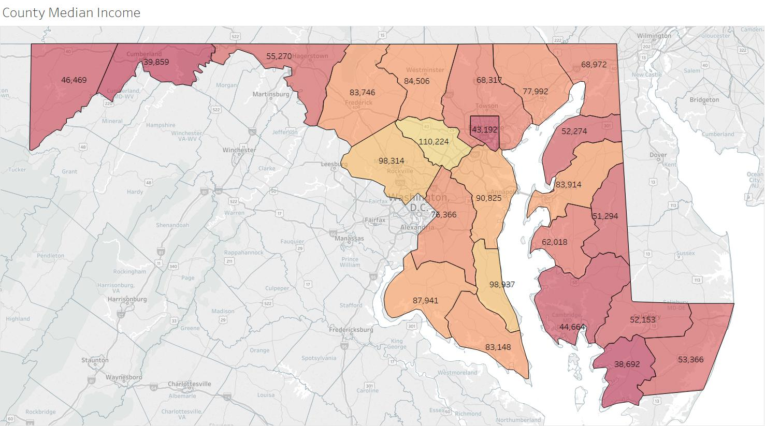

Figure 3

It does not stop with property values; jobs are low value as well.

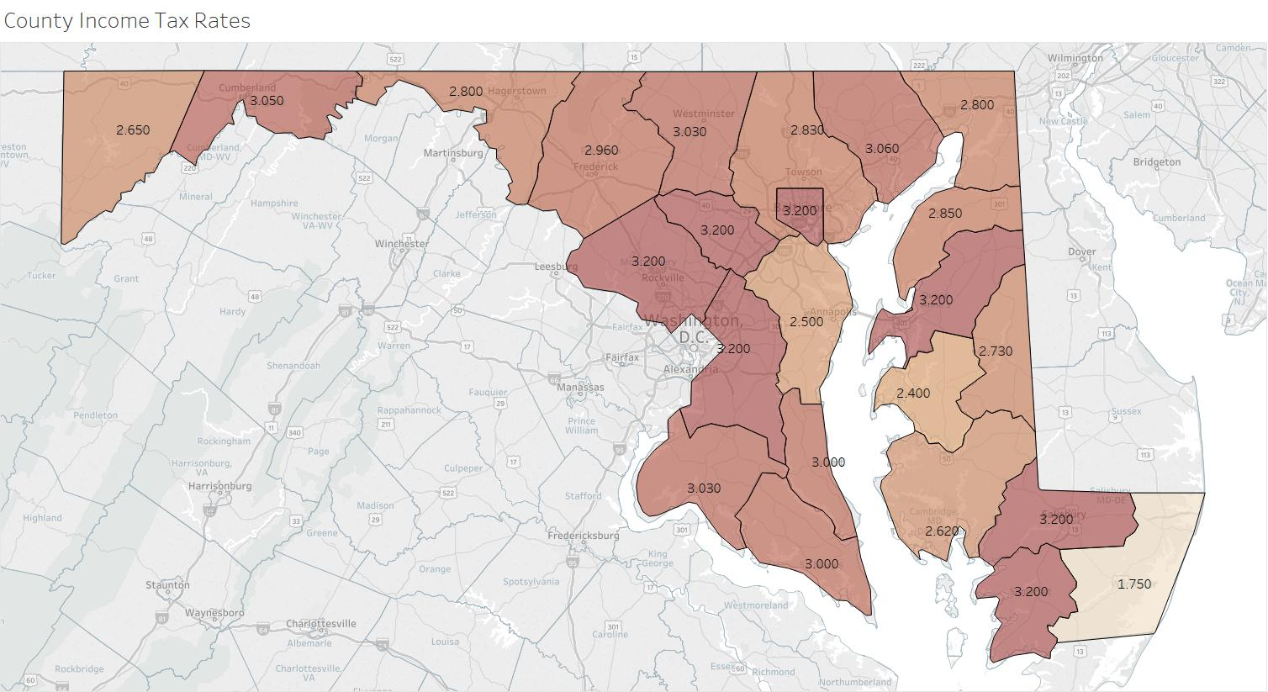

Figure 4

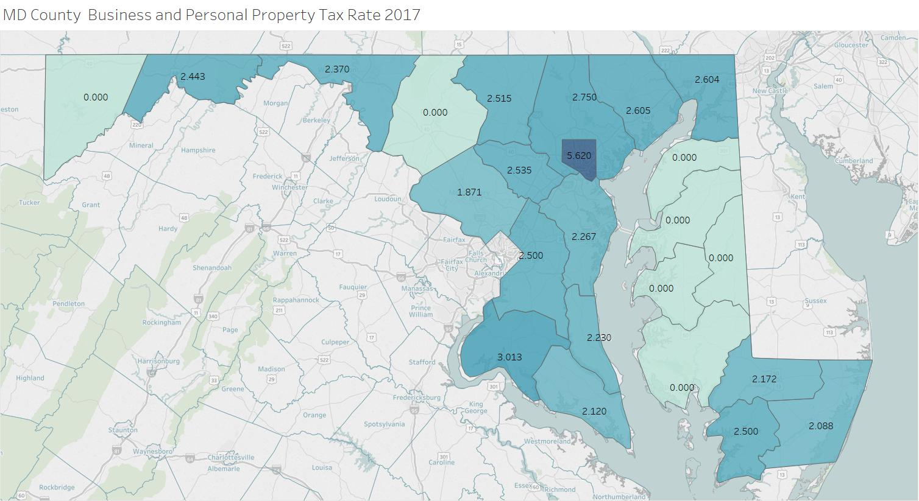

Figure 5

Personal Property tax falls on equipment for the New Economy, not the disappearing industrial base.

Maryland is not an isolated case. We can travel to any conurbation on the East or West Coast:

**Poverty, Taxes and Regional Disparities: The Wealth Gap in Congressional District 4**

Connecticut’s Congressional District Four represents diverging sets of gain and loss: The “Gold Coast” of Greenwich, Darien, and Stamford, cheek by jowl with Bridgeport, one of the poorest cities in the nation.

How can we demonstrate the current state of affairs, and how can we offer real reforms that will not seize the fruits of industriousness, but instead are a tool to bind together the region and distribute the Commonwealth to the entire polity?

How can we equitably provide a “Community Chest” to help more impoverished areas of CD4 stand on their own feet, while not pulling down their more prosperous neighbors?

Can we “share the wealth?” Yes. We can share community-created economic value that lies inherently in the land, a value created by all who live in CD4, from Wilton to Bridgeport.

The task is daunting, and we will present the information graphically to illustrate the impact of these disparities between neighbors.

Here is Congressional District Four. Taken as a unitary, the CD4 is very wealthy indeed. When we reach the artificially constructed city and town borders (each with its unique land use and exclusionary zoning policies), we see very different states of economic health.

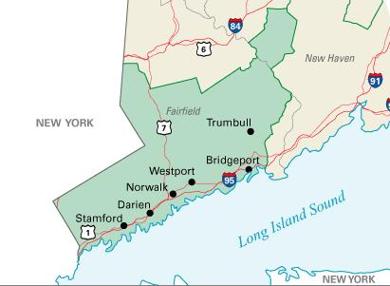

It’s axiomatic that human capital is the future; well-educated and motivated strivers concentrate and pollinate ther human hive.This chart correlates the reality of large populations and low incomes in CD4:

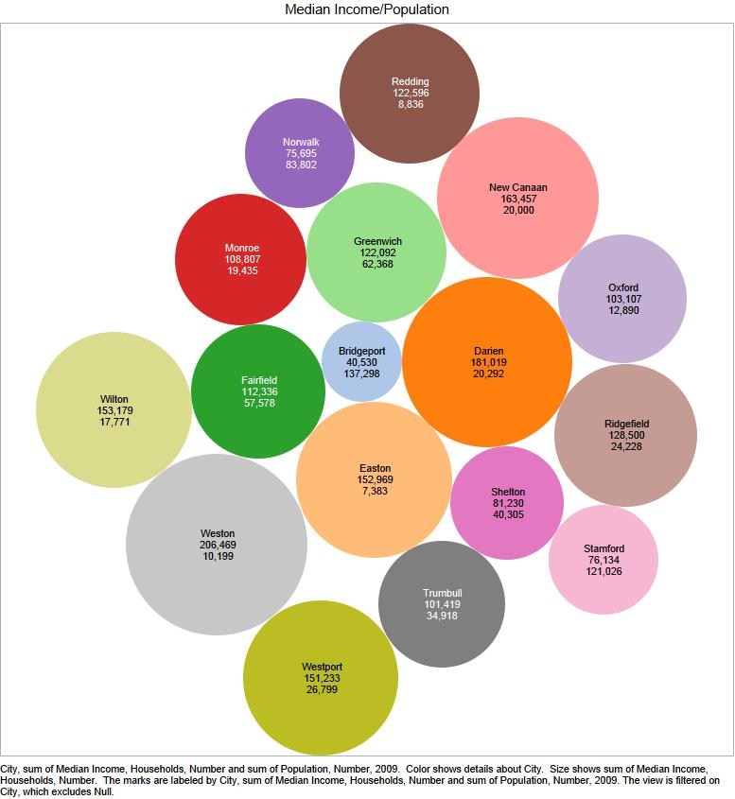

Although Bridgeport is by far the largest city in population, it nearly “disappears” amongst the smaller cities of CD4 because we have calculated the size of the circles on median household family income. Bridgeport is neither wealthy nor middle-class but is instead an enforced enclave of poverty. The next chart illustrates just that fact:

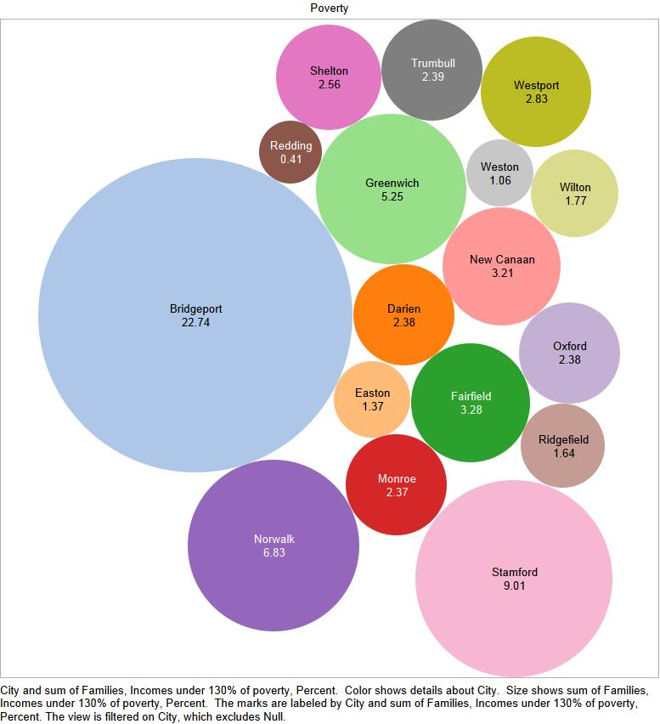

The 2010 poverty rate (little changed since then) is astonishingly high in Bridgeport. Because of an unemployment rate approaching double that of the next highest town (Shelton), there’s little cause to expect recovery for Bridgeport if left on its own. Declining state and federal aid (austerity, in the cliché of the day), Is a grim fact of life.

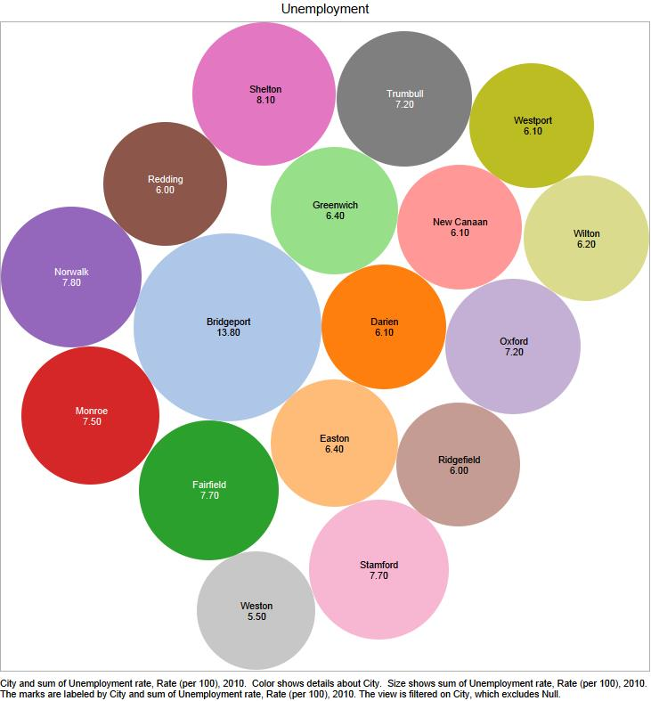

Traditional collection of the products of work, investment, and savings which lie outside of the Commons cannot fill the gap. In the new age of mobility – where incomes both personal and corporate can vanish with the click of a mouse across borders render cyberspace – the Emergency Rooms that are the nations in world centers of poverty demand more than a Band-Aid.

We need to go to the roots (or *radix* from the Latin) for radical change. A doable reform is to share the Commons across neighborhood, city, county, regional, national and international boundaries. How to start?

Speakers at this forum have defined the Commons in its classical and unalterable state. The task now is to quantify in a recognizable way how sharing the Commons would work, without antireform reaction. As we propose that the Commons exists not in things designed, created, invented, built or bought by humanity, we can measure our Commons in various ways. The earth, rainforest, the oceans and the air we breathe are just some examples of the Commons that exist with an intangible value that serves our very survival.

One aspect of the Commons is the value of land. It is an excellent place to start our discussion here as we move forward. How would this work? In CD4, each town and city has an accounting of the value of the land and buildings that exist within the city. Traditionally taxation is the tool with which to fund the engines of the community to provide equity, justice, and fairness. These are the values of the municipalities in CD4:

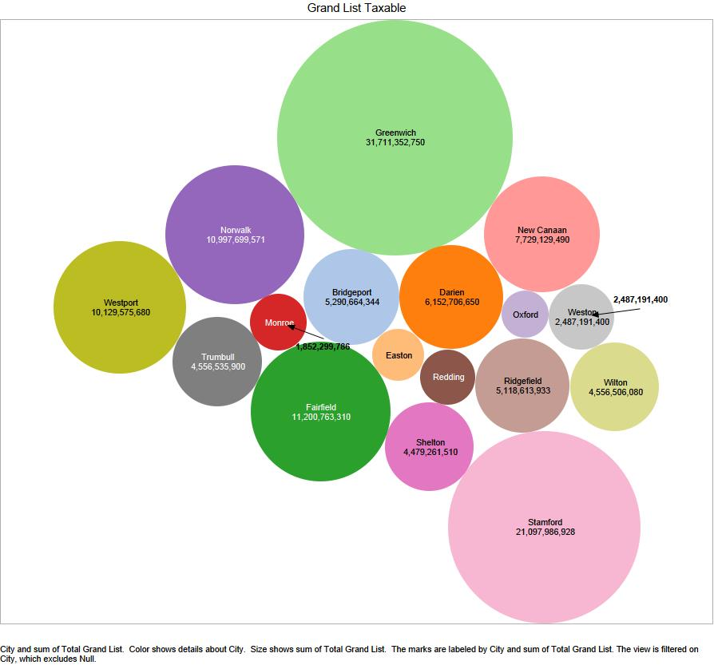

What do the particularly wealthy cities do with this wealth that rests mostly in land and property? Naturally, they keep it for themselves in the form of dramatically low taxes and tax rates: Bridgeport’s tax rate, where people are least able to pay, layout nearly 4 ½% a year in taxes. In fabled Greenwich, the tax rate is less than 1%. Change is needed.

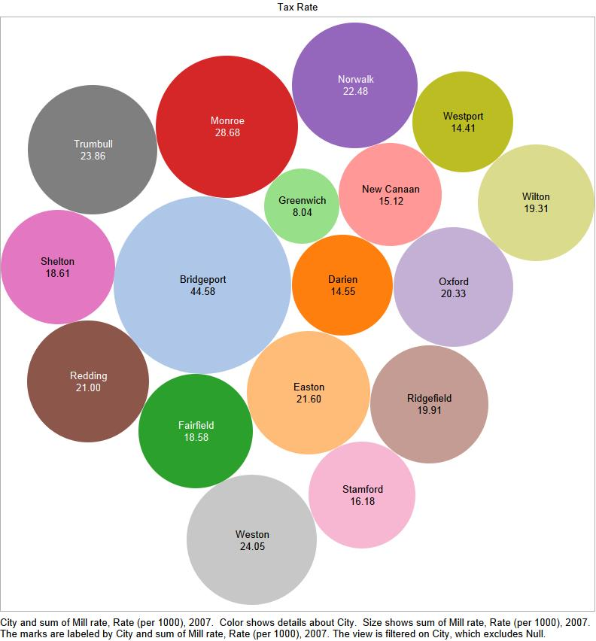

The change that is practical and has been done already in Pennsylvania, Australia, Taiwan, Estonia and many other jurisdictions that try to help all the people is to transfer back to the Commons the economic value of land. We have tried to create a basic model based upon pre-existing and precedential taxation systems in the United States. In other nations, the same systems would also be the basis for this radical reform, as they would then be displaced by the claim of the community to the Commons. What is the plan? Here we have determined an imputed economic rent of 2 ½% per year. We have averaged the assessed value of land for towns ranging from wealth to poverty-stricken. Land value as a share drops as the presence of poverty and its effects play out, e.g. Greenwich and Dairen, consist about 50% as land value, Bridgeport about 25%. The land value data based upon market rate assessed values rounded for purposes of illustration. We believe that these shares on a local, regional or national basis can be replicated anywhere in the world. The law of economic rent in the Commons is universal.

The result of this share of economic rent is thus:

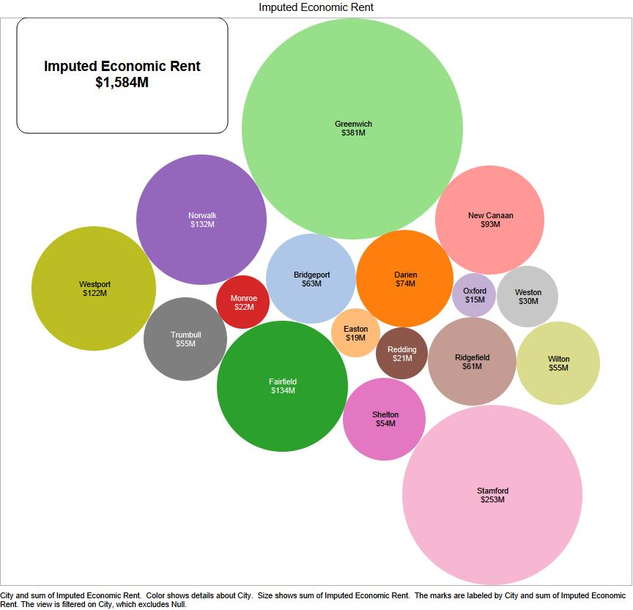

**Conclusion:**

Unleashing the Common Wealth to fund the needs of all of the community has been effectively hidden for centuries. Only now, with the failures of the past century super-state and super-corporatist policies that concentrate publicly created value into the hands of a very few – be they government or corporations – that these questions started to arise. We believe these fact-based, but straightforward demonstrations make this an urgent issue for our times.